Job Description

This job description is to be read in conjunction with the For Children & Young People Statement of Main Terms of Employment for this role and should be reviewed at least annually.

Job title: | CYP Manager
Reporting to: | Chief Executive Officer (CEO)
Key connections: | - Operations Manager  - Clinical Services Manager  - Finance Manager  - Comms and Marketing Manager
Line Management of: | - CYP Practitioners
Location: | Based at 4YP Hub, 14 Lower Brook Street, Ipswich, IP4 1AP. (From Sept2026 – Unit 6, Regatta Quay, Ipswich, IP4 1FH)  Travel to other locations is an expectation of this role.
Working hours: | 37 hours per week.  Worked flexibly within a regular pattern, including some evening work when required, by agreement with the CEO, in fulfilling the requirements of the role.

Context:
4YP believes that all children, young people and young adults should have somewhere safe
to go, something positive to do and someone trusted to connect and journey with.

The mission of the charity is to,
- respond with agility to the changing needs of children, young people and young adults as they occur;
- ensure that children, young people and young adults are confident to transition to the next stages of their lives; and,
- ensure that children, young people and young adults are enabled to thrive and fulfil their potential.

Our intention is that children, young people and young adults have increased opportunities to shape the charity and its services. During the summer of 2026 a new premises will be completed and we have a desire to ensure a more joined up approach to delivering clinical and wraparound services for children and young people, so that they and their families have ‘one front door’.

Whilst a few of our services and contracts have come to a natural end over the last year we now have an opportunity to shape and develop something fresh in direct response to what young people want and need and with them as part of that process.

Culture:
4YP hope that all staff are enabled to work in accordance with their own values. We have two overarching cultural norms and a Code of Conduct which underpin our workplace and organisational culture:

- Staff and volunteers first - without our staff and volunteers there is no service.

- Our beneficiaries are paramount - in any given moment; the child, young person or young adult is the most important person in our world.

- Code of Conduct - a zero-tolerance approach is taken to non-adherence, especially how we engage with each other, children/young people and stakeholders.

Job Purpose:
As a member of the Strategic Leadership Team (SLT), be responsible for the planning, resourcing, leadership and evaluation of a programme of activity for children, young people and young adults (CYP) that fulfils the vision and mission of the charity.

To manage, support and develop the team of CYP Practitioners to deliver that programme.

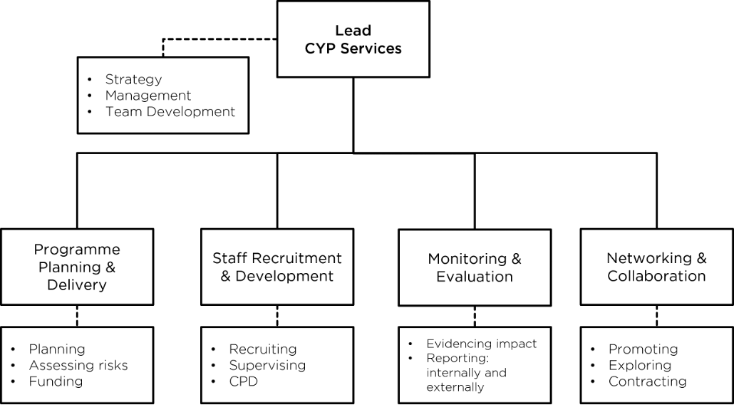

Principle responsibilities:
- To provide effective leadership and support to the CYP Service and its staff.

- To plan and ensure the delivery of an ongoing needs-led programme of services for CYP that is synergetic with clinical services.

- To lead the recruitment, induction, supervision and professional development of appropriately qualified and trained staff (as required for delivering safe and high-quality services for CYP that meet their needs and expectations,)

- To support the collection of data necessary for monitoring and evaluating the quality and effectiveness of CYP Services and the impact of interventions on the lives of CYP.

- To proactively engage in networking that enables the development of partnerships and collaborative working with others, and that benefits CYP and/or the organisation.

- To be a Designated Safeguarding Lead (alongside the Lead Counsellors) for the CYP Team [training is provided].

There may be other occasional and appropriate responsibilities to undertake, as reasonably requested by the CEO.

Objectives and deliverables:

Provide effective leadership.
- Contribute as a member of the SLT to shaping the strategy of the organisation by:
- Providing insight and promoting the needs of CYP;
- Making recommendations for the required programmes of activities;
- Enabling the development of a holistic service for CYP;
- Sharing in wider decision making
- Line Manage, and coach and mentor as is appropriate, CYP Practitioners.
- Organise, plan and lead regular opportunities for the CYP Team to meet, reflect, learn and develop together.
- Attend CYP activities on an ad hoc basis when necessary.

Develop CYP services.
- Strategically plan a programme of activities for CYP, in response to perceived and identified needs, working with the Clinical Services Manager to ensure than it is synergetic with any Clinical Services Offered.
- Advise and support the CEO, Operations Manager and externally contracted Bid Writer regarding the securing of funds necessary for delivering CYP services and the prudent management CYP programme funds.

- Lead CYP Recruitment and Development
- Recruit staff necessary for the delivery of CYP services, by,
- Advising the CEO of the required roles, providing draft job descriptions.
- Work with the Communications and Marketing Officer to ensure CYP roles are well advertised via the appropriate channels.
- Work with the Operations Manager to ensure shortlisting, interviews, appointments and induction are undertaken in accordance with the necessary employment practices and safer recruitment.
- Facilitate the external professional supervision of CYP frontline practitioners.
- Explore and create opportunities for the continued professional development of the CYP workforce.

Monitor and evaluate the CYP programme.
- Implement effective models for the monitoring and evaluating the CYP programme that evidence the impact on the lives and journeys of CYP.
- Support the CEO with the reporting of impact of the CYP programme to the Board of Trustees/Directors, notably in accordance with achieving the vision, mission and strategic plan for the organisation.
- Work with the Operations Manager to ensure that monitoring reports are provided to funders in a timely manner, contributing the required information, including statistical data and anecdotal evidence.

Engage in networking and increase collaboration.
- Promote CYP services as a representative and ambassador for the organisation, actively engaging with partner organisations and personnel, and participating in appropriate networks.
- Explore, develop and maximise opportunities for partnership and collaborative working that benefits CYP and/or the organisation.
- Advise the CEO and Operations Manager, on the drafting of Service Level Agreements and contractual arrangements for the delivery of CYP services, overseeing and monitoring those agreements when they are in place.

Safeguarding.
- Be the Designated Safeguarding Lead (DSL) for the CYP service, alongside the DSLs for Counselling [Lead Counsellors for the Hub and Schools respectively].
- Attending Safeguarding Team meetings.
- Identify and support the development of CYP Practitioners to be Deputy DSLs.

This job description is provided as a guide to the principal responsibilities of the post and to aid the understanding of the job. It does not form part of the Contract of Employment.

It may be varied from time to time in response to the changing needs of CYP and/or funding. It will be discussed regularly at line management one-to-ones and reviewed at least annually as part of the annual wellbeing and performance review.

Last reviewed and amended: 16 June 2026

Person Specification

(A = Application / I = Interview)

Experience | Essential | Desirable | Method
Proven experience of working in a similar role directly with young people. | ü |  | A, I
Experience of planning, delivering and evaluating youth work programmes. | ü |  | A, I
Experience of line management or supervising staff/volunteers | ü |  | A,I
Experience of multi-agency partnership working (schools, local authorities, community groups etc) |  | ü | A,I
Experience contributing to reports for funders/stakeholders |  | ü | A,I
Skills & Abilities
Excellent relationship building skills with young people, staff and partners | ü |  | A, I
Strong leadership and team management skills | ü |  | A, I
Ability to plan strategically while also delivering operationally | ü |  | A, I
Effective communication skills (written and verbal) including report writing | ü |  | I
Ability to manage competing priorities and work under pressure | ü |  | I
Skills in facilitation, mentoring and coaching |  | ü | I
Ability to develop new partnerships and secure opportunities |  | ü | I
Proficiency in standard office software, such as Word and Excel. | ü |  | A, I
Knowledge and Understanding
A sound knowledge and understanding of the issues affecting young people and the services available to support them | ü |  | A, I
Understanding of and commitment to equal opportunities | ü |  | A, I
A developed knowledge and understanding of relevant Safeguarding and Health & Safety requirements when working with children and young people | ü |  | A, I
Understanding of relevant legislation, regulations, and governance best practices, including GDPR. |  | ü | A, I
Awareness of national youth policy and frameworks |  | ü
Qualifications
A recognised qualification in Youth Work, Community Development, Social Work or a related field (eg, JNC Level 3-6 Youth work) | ü |  | A, I
Commitment to continuous professional development and willingness to undertake any training as may be required | ü |  | A, I
Personal Attributes
Passionate about improving outcomes for young people | ü |  | I
Values-led, with a strong commitment to inclusion equity and youth voice | ü |  | I
Resilient and able to handle challenging situations calmly | ü |  | I
Collaborative and able to inspire others | ü |  | I
Other Requirements
Willingness to work flexible hours, including evenings and occasional weekends | ü |  | I
Enhanced DBS check (4YP will obtain on successful appointment) | ü |  | I
Ability to travel locally as required | ü |  | I

This job description and person specification is provided as a guide to the principal responsibilities of the post and to aid the understanding of the job. It does not form part of the Contract of Employment.

It may be varied from time to time in response to the changing needs of CYP and/or funding. It will be discussed regularly at line management one-to-ones and reviewed at least annually as part of the annual wellbeing and performance review.

Last Reviewed and amended: 22 June 2026

